Chapter 14, Solution 22.

Find the transfer function H(ω) with the Bode magnitude plot shown in
Fig. 14.74.

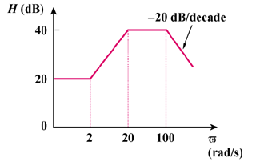
ω
(rad/s)

Figure 14.74
For Prob. 14.22.

Solution

A zero of slope at
A pole of slope at
A pole of slope at

Hence,

